## Problem

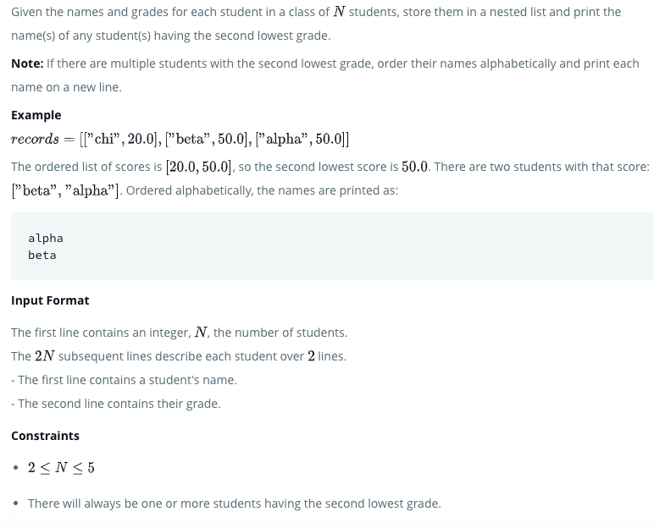

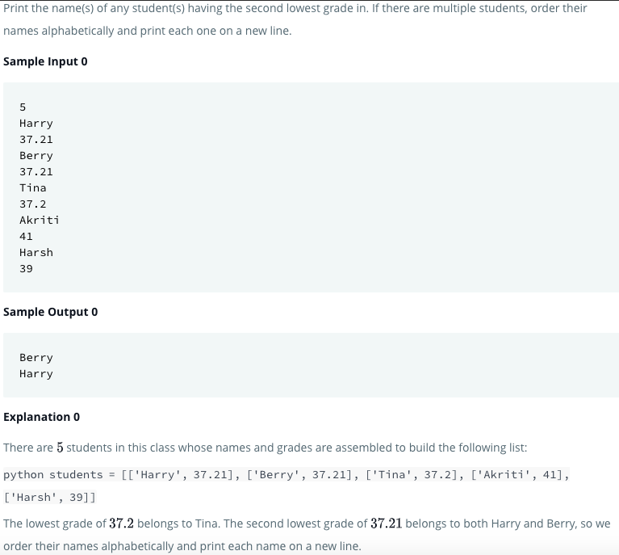

## Solution

d={} #1

for _ in range(int(raw_input())): #2

Name=raw_input() #3

Grade=float(raw_input()) #4

d[Name]=Grade #5

v=d.values()#6

second=sorted(list(set(v)))[1] #7

second_lowest=[] #8

for key,value in d.items(): #9

if value==second: #10

second_lowest.append(key) #11

second_lowest.sort() #12

for name in second_lowest: #13

print name #14

## Instructions

[@1](https://www.hackerrank.com/1)) Empty dictionary.

[@2](https://www.hackerrank.com/2)) Range for number of students.

[@3](https://www.hackerrank.com/3)) Accepting name of the student.

[@4](https://www.hackerrank.com/4)) Accepting the grade of the student.

[@5](https://www.hackerrank.com/5)) Assigning name as key and grade as value for the dictionary.

[@6](https://www.hackerrank.com/6)) Obtaining the values of dictionary(all grades of students.

[@7](https://www.hackerrank.com/7)) Remoing duplicte grades by using set data type , changing it to list, sorting in ascending order and taking the second lowest grade.

[@8](https://www.hackerrank.com/8)) Declaring an empty list for storing the name of the students who got the second lowest grade.

[@9](https://www.hackerrank.com/9)) Going through the name and grade of each students by using items() method of dictionary.

[@10](https://www.hackerrank.com/10)) Checking whether the grade is equal to the second lowest grade.

[@11](https://www.hackerrank.com/11)) If yes , append it to the second_lowest list.

[@12](https://www.hackerrank.com/12)) bSorting the name of students in asceding order

[@13](https://www.hackerrank.com/13)) Going through the name of each students who got the second lowes grade.

[@14](https://www.hackerrank.com/14)) Printing each name of students in seperate line.

## Python3

if __name__ == '__main__':

students = []

for _ in range(int(input())):

name = input()

score = float(input())

students.append([name,score])

x = 99999

for i in range(len(students)):

if x > float(students[i][1]):

x = float(students[i][1])

y = 999999

for i in range(len(students)):

if float(students[i][1]) > float(x) and y > float(students[i][1]):

y = float(students[i][1])

runner = []

for i in range(len(students)):

if float(students[i][1]) == float(y):

runner.append(students[i][0])

runner = sorted(runner)

for i in range(len(runner)):

print(runner[i])